# kafka-tutorial

## Create Account

1. open signup page of confluent Kafka

[[Confluent Kafka](https://www.confluent.io/get-started/)]

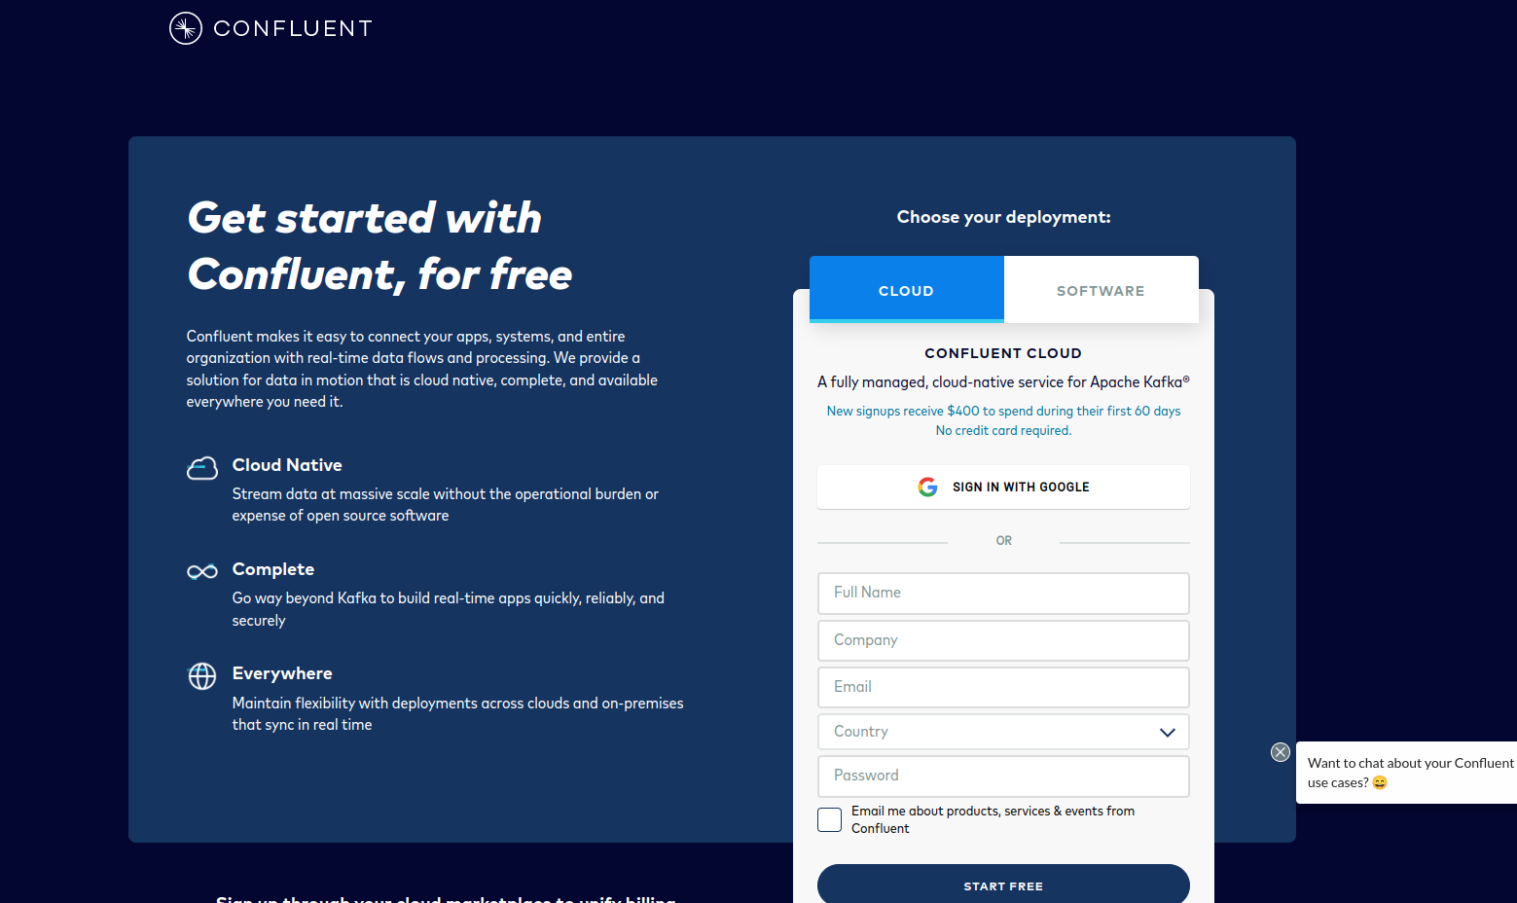

2. Go to Confluent [[Login page](https://confluent.cloud/signup/idp/google-oauth2?signup_source=iosocial&iov_id=49a3b680-a2a1-4f52-8c1d-888fae73120e&_ga=2.145483828.1681359053.1653306300-338132655.1653306300)]

